KELCO INDUSTRIES
LEAD TO QUOTE
PROCESS FLOW DOCUMENT

Login to Role: Sales Manager
Sales Preferences
The Sales Preferences page lets sales administrators set customer status preferences that specify how the company should use the Sales Automation feature.

Navigate to, Setup-> Sales -> Sales Preferences.

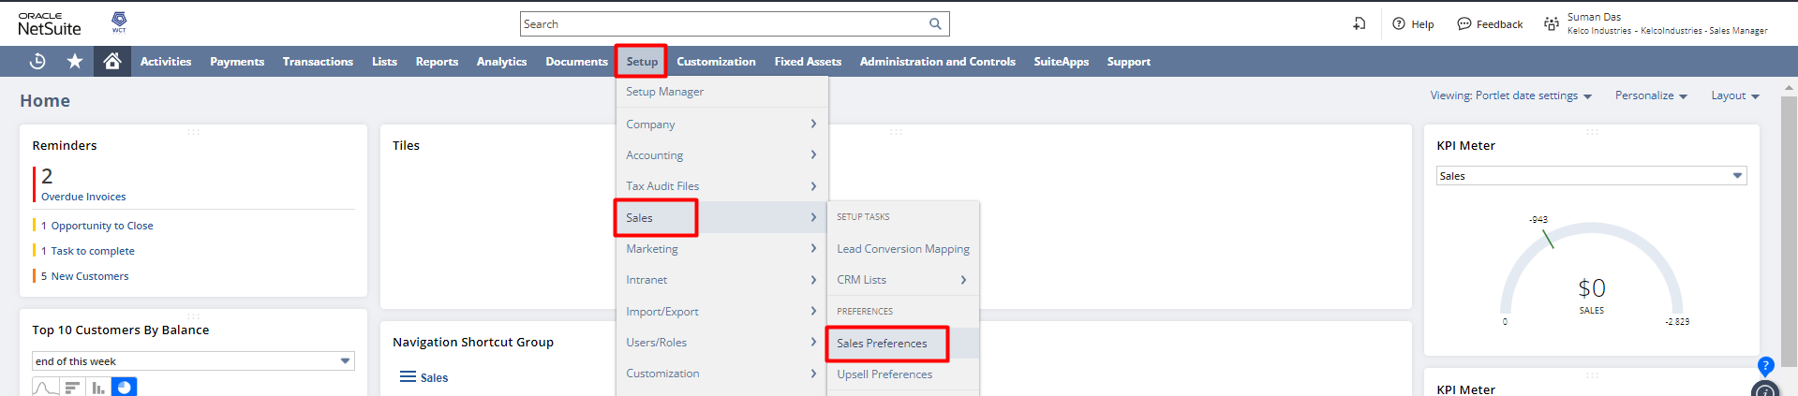

Select the required preferences and Save the record.

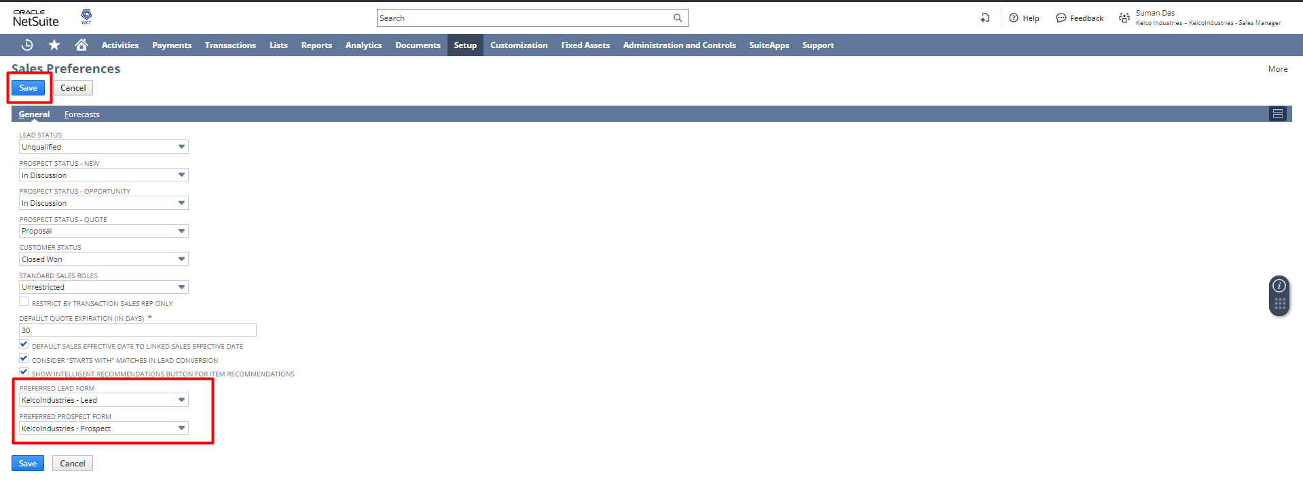

Customer Status
The customer status record describes a lead, prospect, or customer's stage in the sales cycle.
Navigate to, Setup-> Sales -> Customer Statuses.

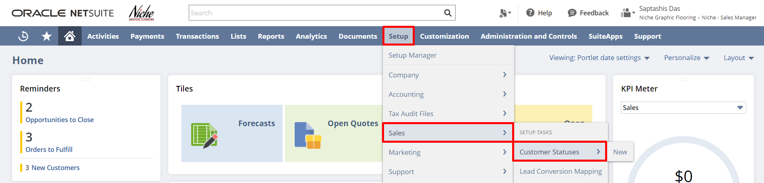

Here is the list of Customer Statuses.

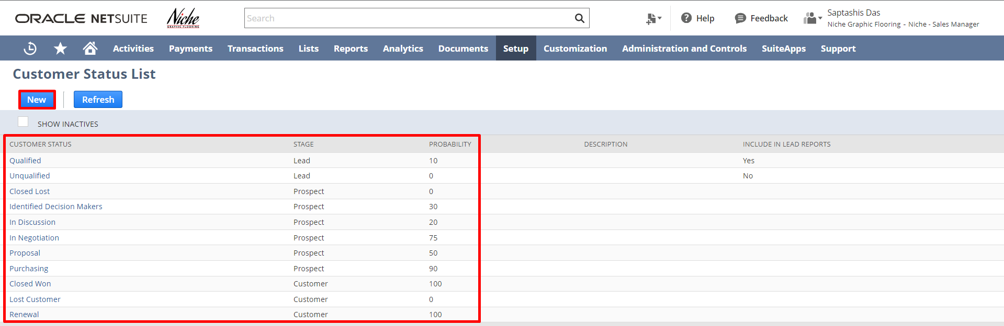

To create a new customer status, click on the New button. Fill in the value of Status (The name of the new status), Stage (select Lead, Prospect, or Customer as the stage), and probability (select the probability as per the selected stage).

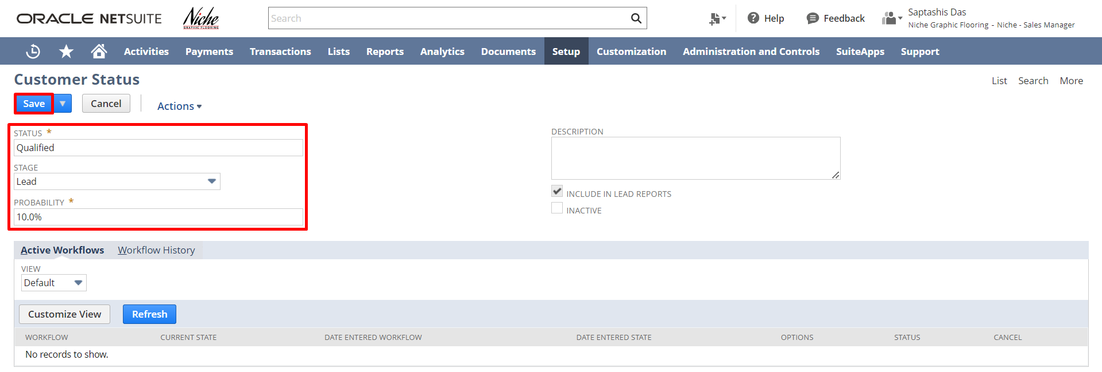

Click on the Save button to save the record.

Login to Role: Sales

CRM List

To create new records for Customer Relationship Management (CRM) features navigate to
Setup-> Sales-> CRM Lists.

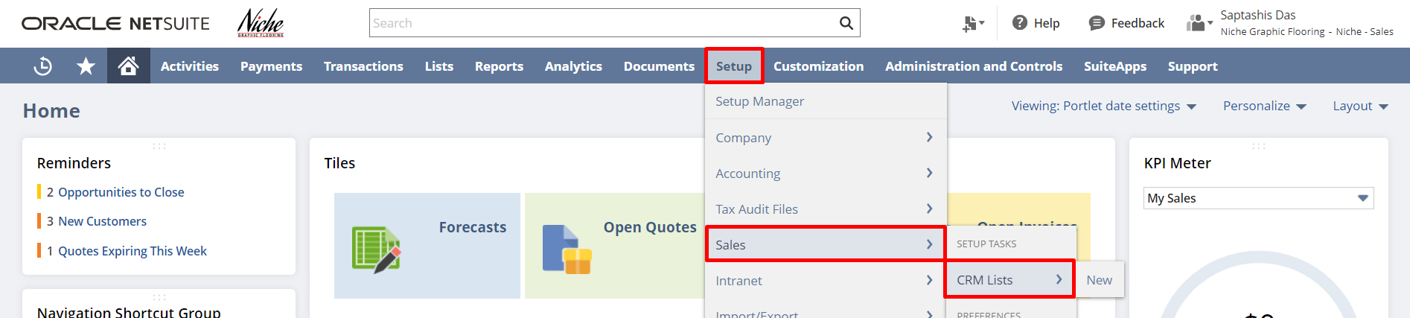

Here is the CRM List:

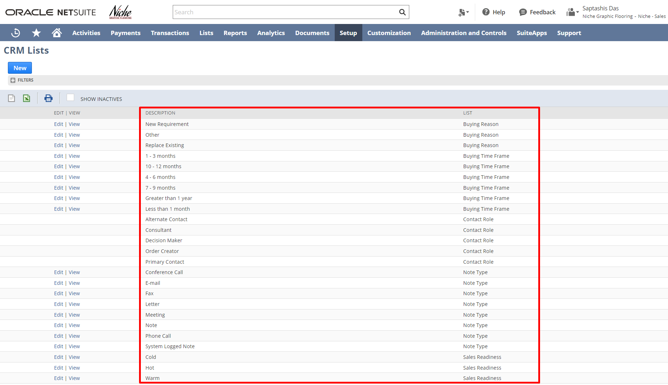

To create a new CRM list, click on the New button.
After clicking the New button user will get a list to create a new CRM as:
- Buying Reason
- Buying Time Frame
- Contact Category: Buying time frame indicates when a customer intends to purchase.
- Contact Role
- Note Type

- Partner Category/Role
- Sales Readiness: Sales readiness describes how close a lead, prospect, or customer is to making a purchase.
- Win/ Loss Reason: Use Win-Loss reasons to indicate why an opportunity is won or lost.

Select the required category to create the CRM lists.

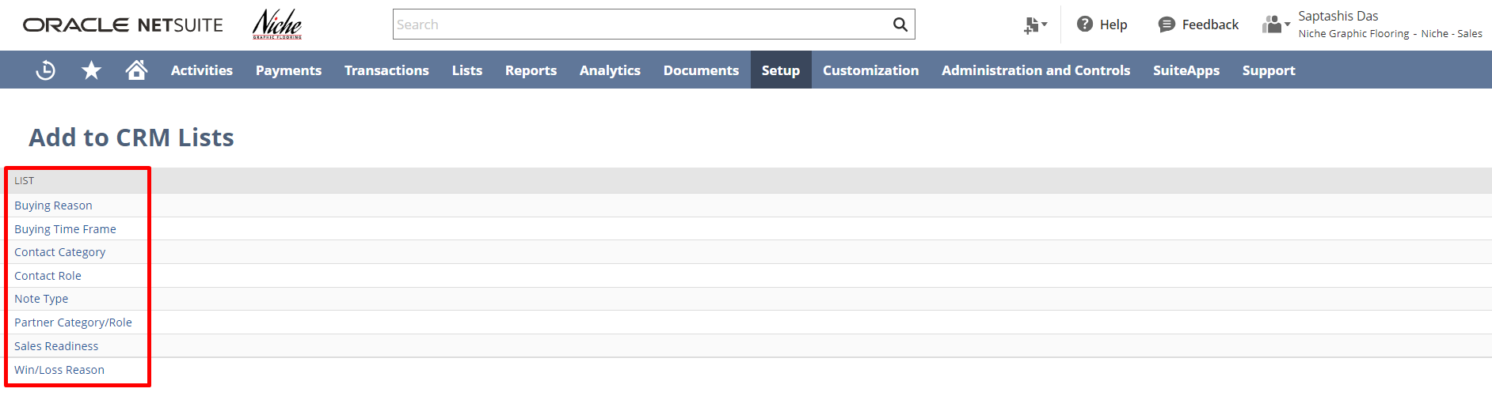

Enter the reason and save the record.

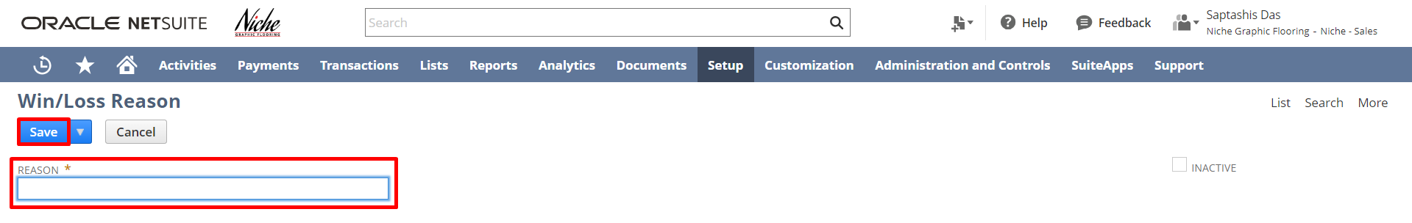

After creating the list user can filter out the list of required types from the filter option as shown below:

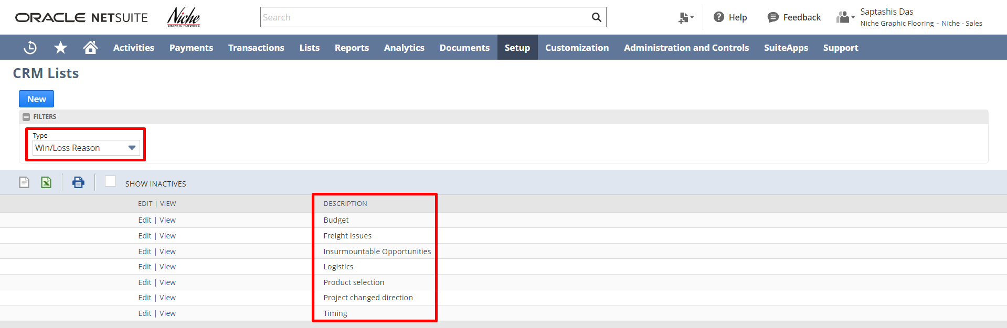

Creating Lead
Navigation: Lists -> Relationships -> Leads -> New
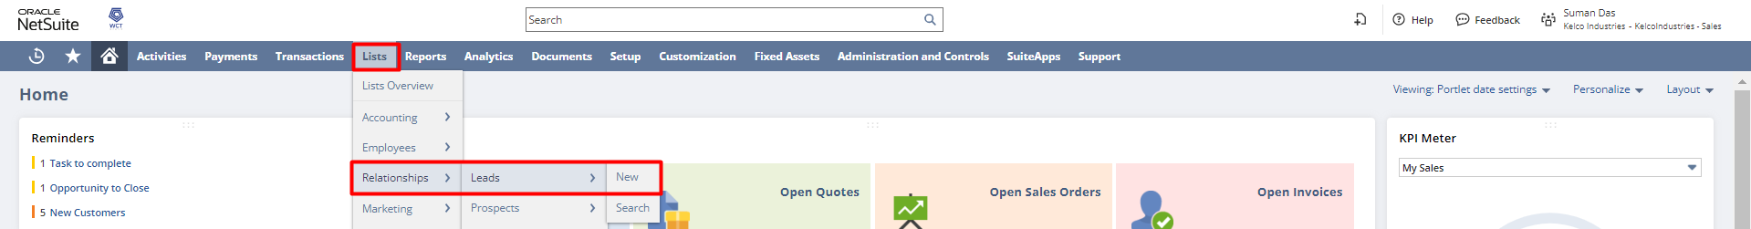

In the Lead form select Type, enter the Company/Individual Name, Primary Subsidiary (If multiple subsidiaries are present), Lead Status, Email, and Sales Rep (If a sales rep is associated).
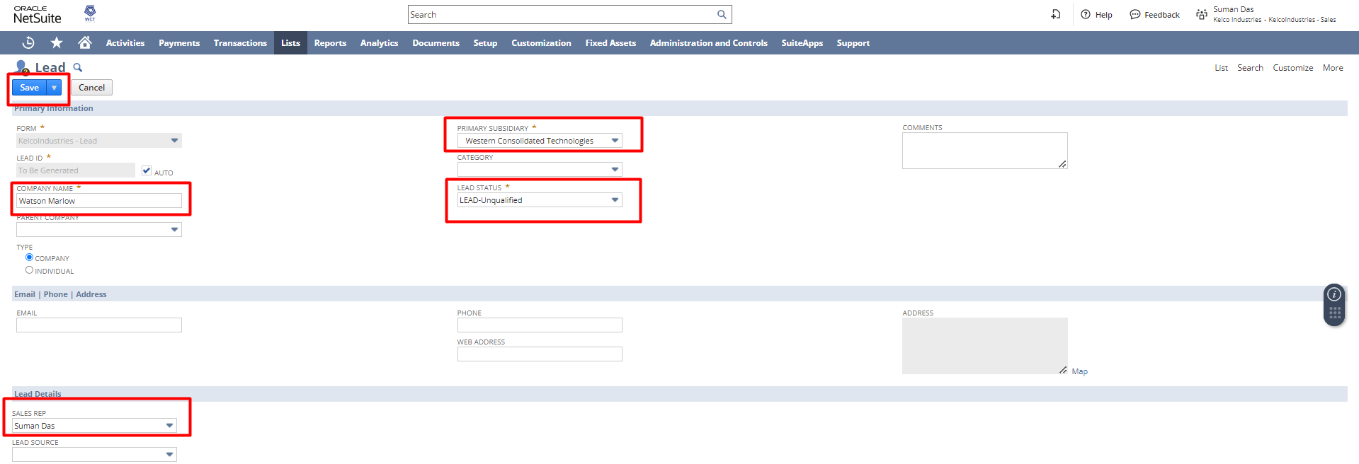

Under the Qualification subtab, enter the following:
- Estimated Budget: Enter the estimated budget the prospect or customer has for this opportunity.
- Buying Reason: Choose the prospect or customer's reason for buying from your company.
- Budget Approved: Check this box if the customer's budget has been approved.
- Sales Readiness: Choose how close the prospect or customer is to purchasing.
- Buying Time Frame: Select the time frame for the prospect or customer to purchase.
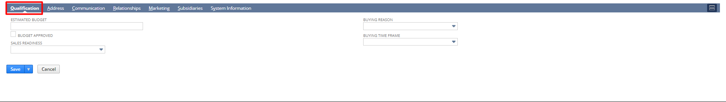

Under the Address subtab, click the Pencil icon and enter the address. If this is the default shipping and billing address then check the checkboxes.

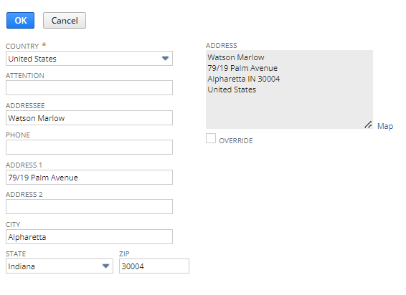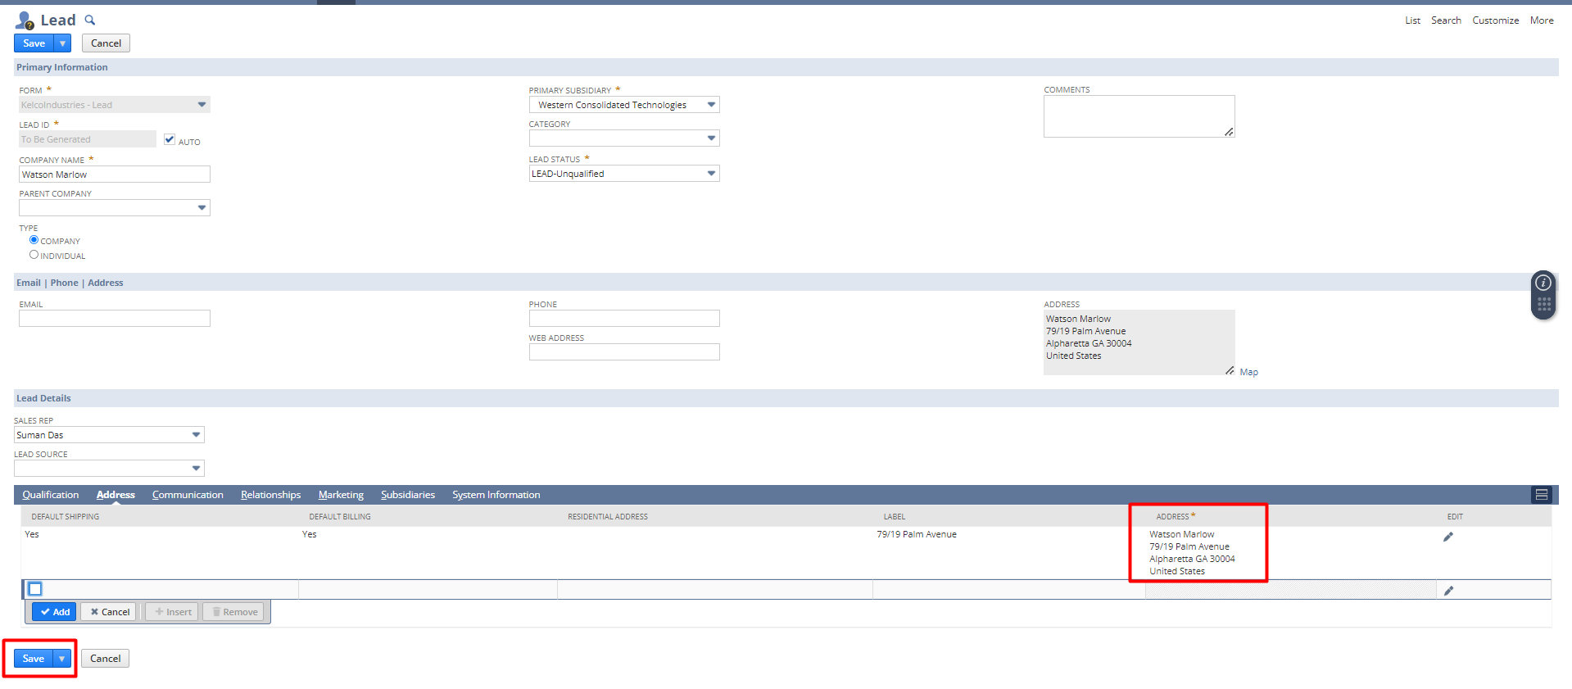
Click Save.
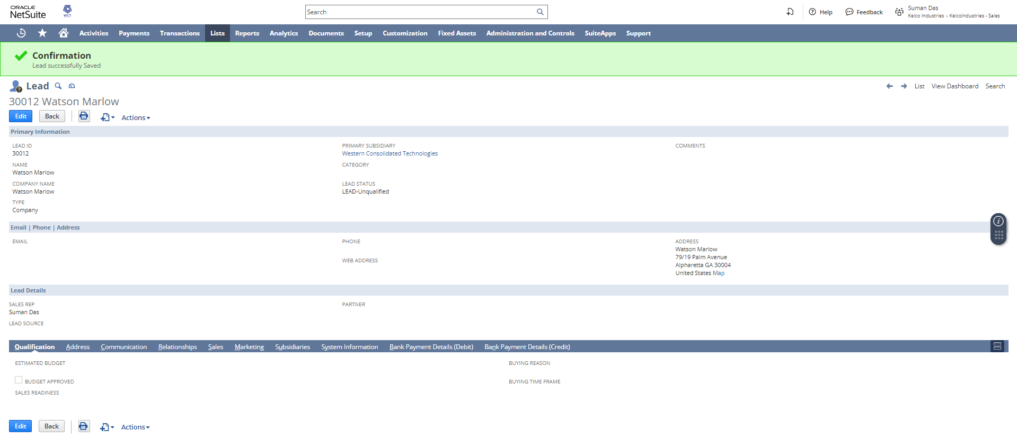

Creating Opportunities
Navigation: Transactions -> Sales -> Create Opportunities
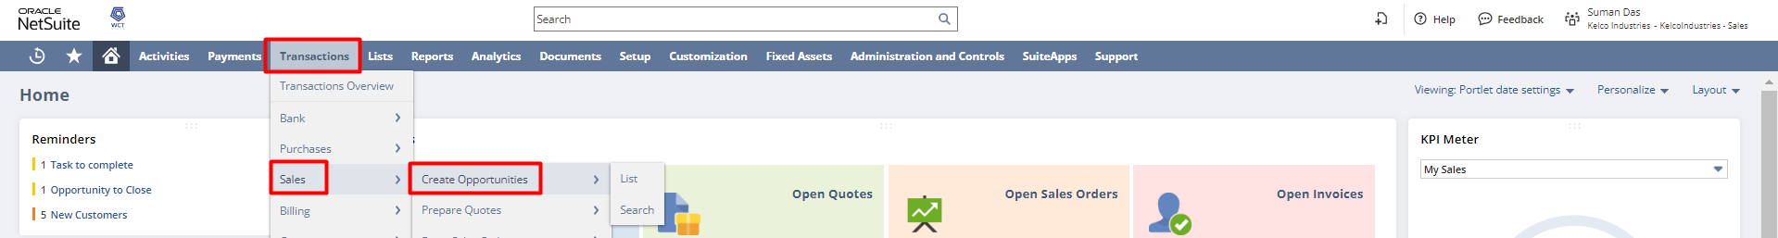
In the Opportunity, form select Company, enter the Date, Expected Close, Status, Probability, and Projected Total. If required enter the Location and Win/Loss Reason.
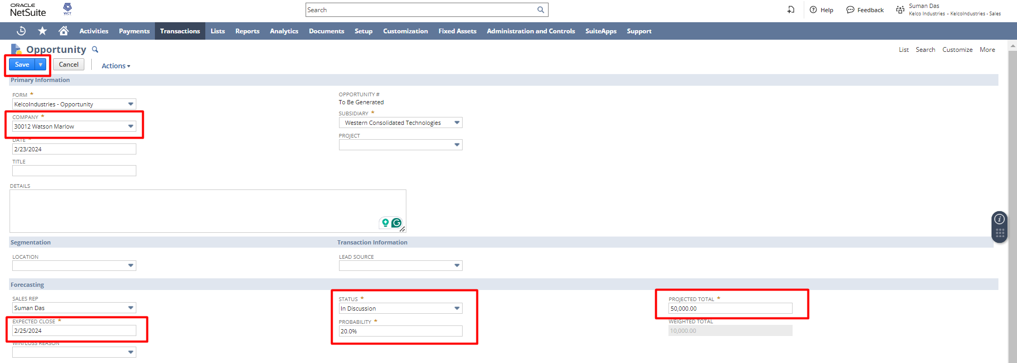
Although the item subtab is not a mandatory section, users can enter the Item from the dropdown, enter a quantity, and provide the rate if required.
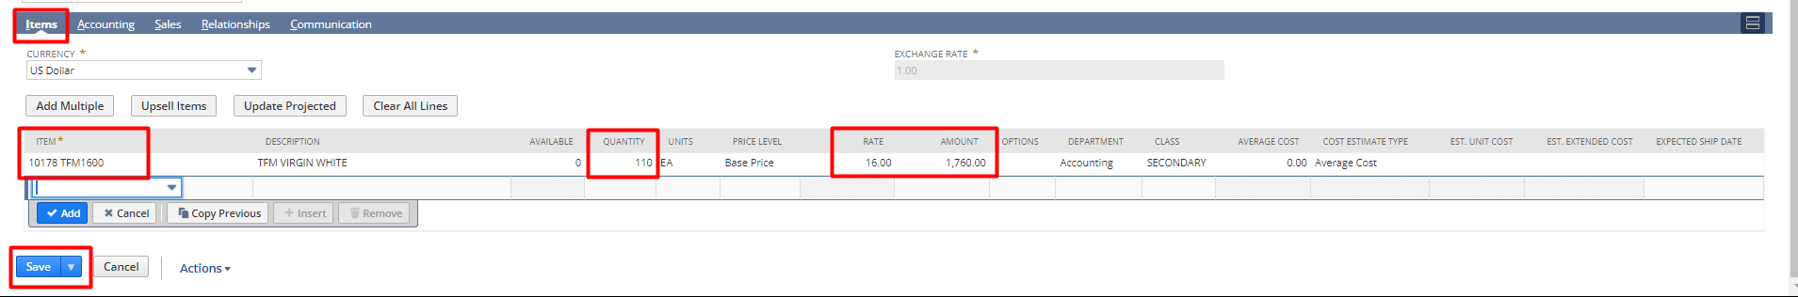
Click Save.
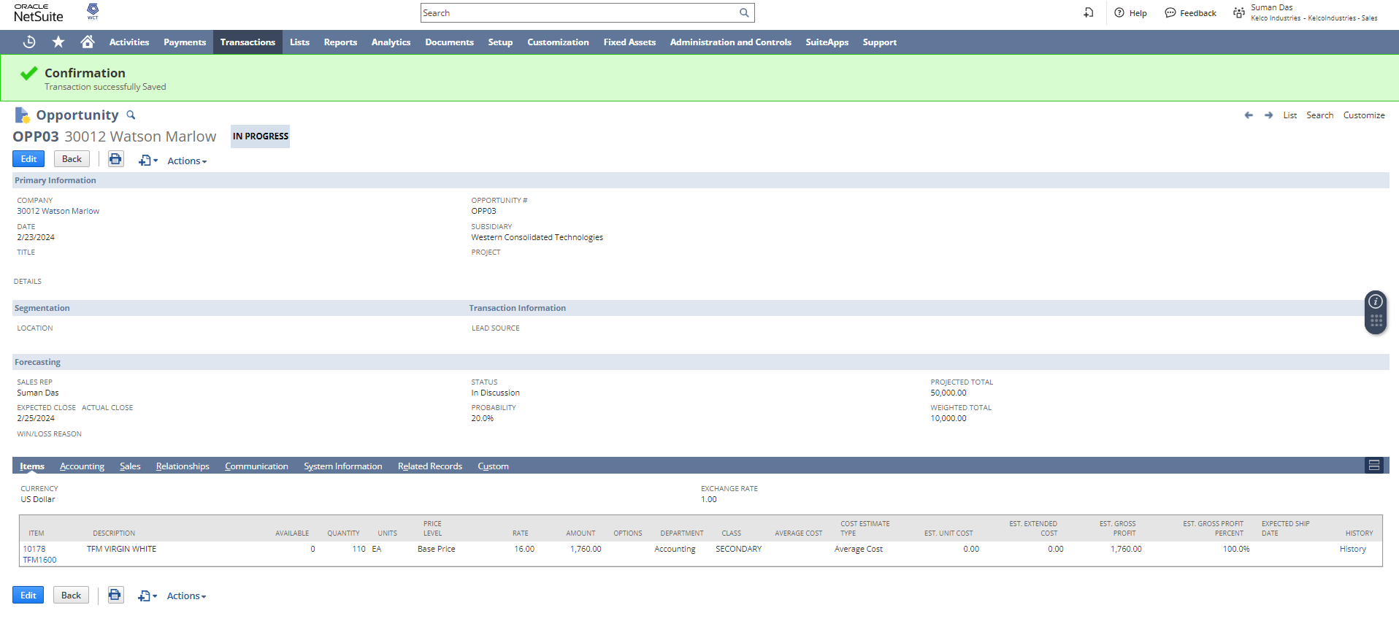
NOTE: If an Opportunity is created with Status selected as “Closed Won” then the Lead gets directly converted into a customer.

As we have created the opportunity the Lead gets converted into a Prospect.
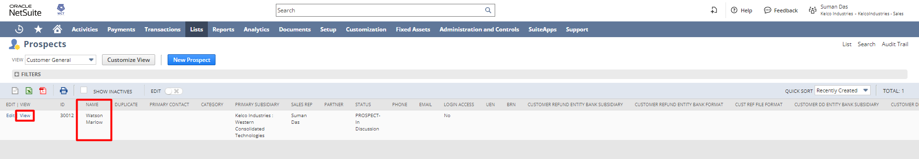
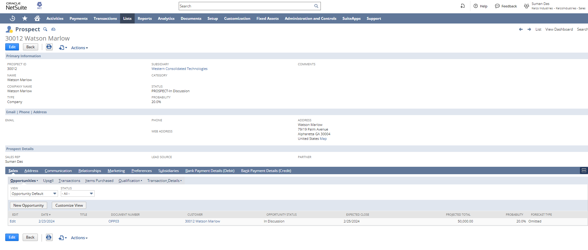

Creating Quotes
Navigation: Opportunity Page -> Create New Icon -> Quotes
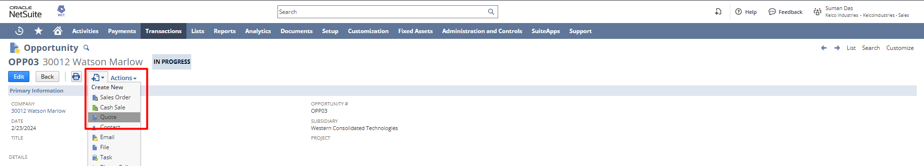

As the Quote page opens all the required details get auto-populated from the opportunity, now just click Save.
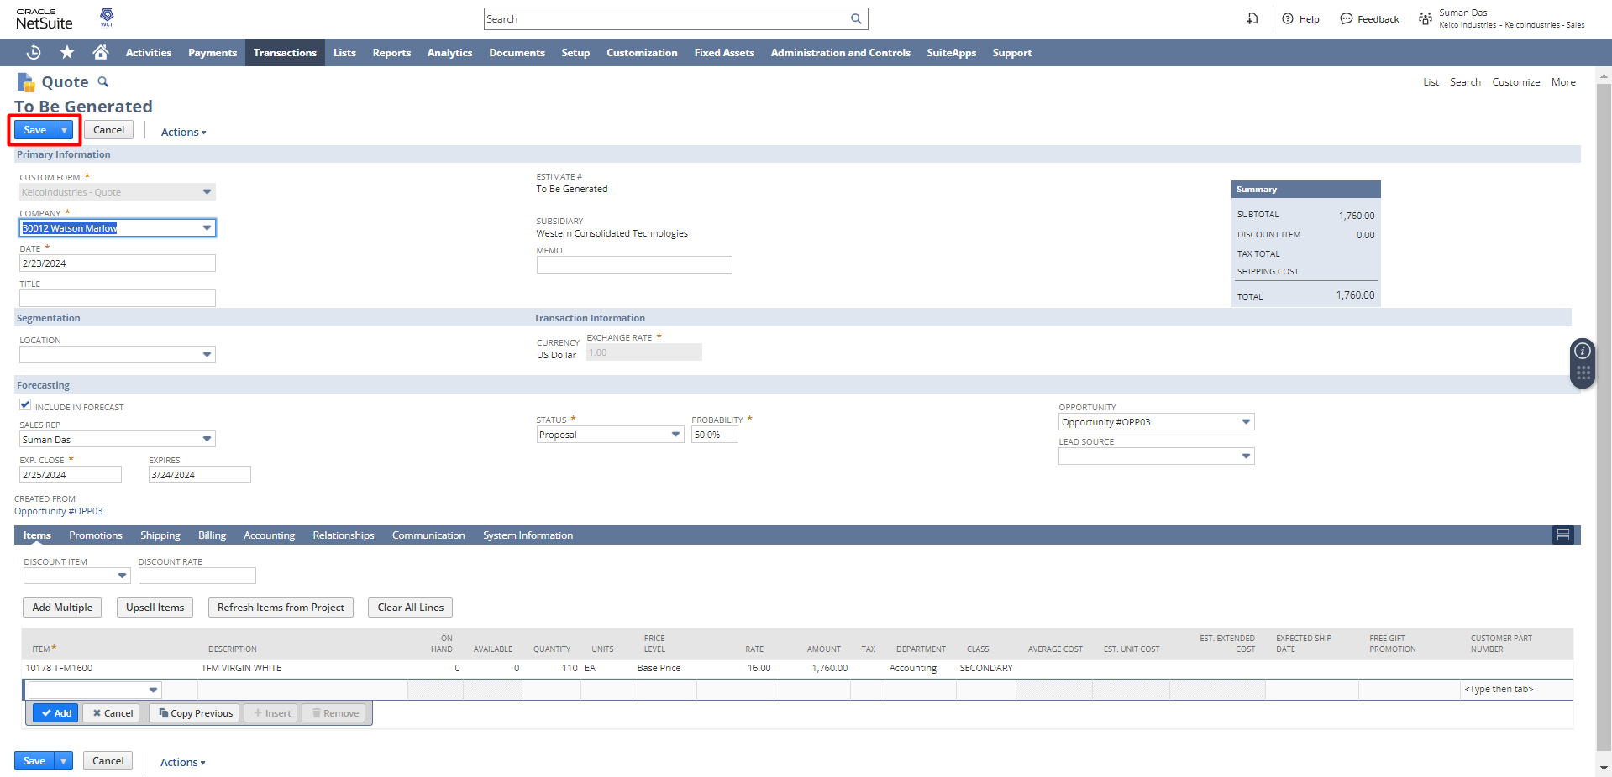
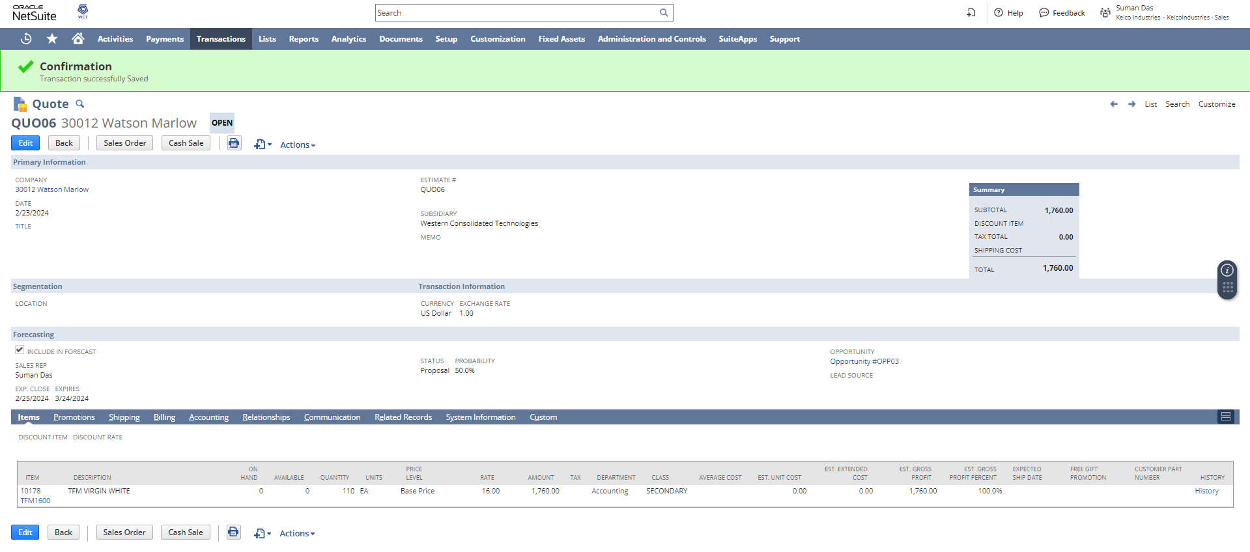
To print the quote click on the print button.
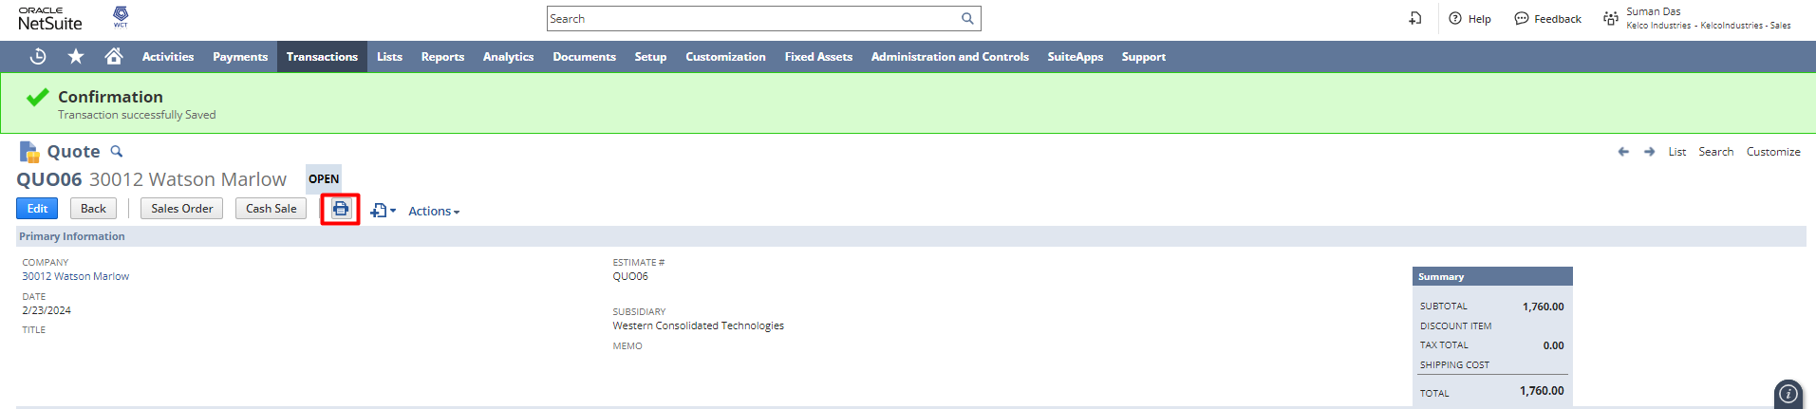
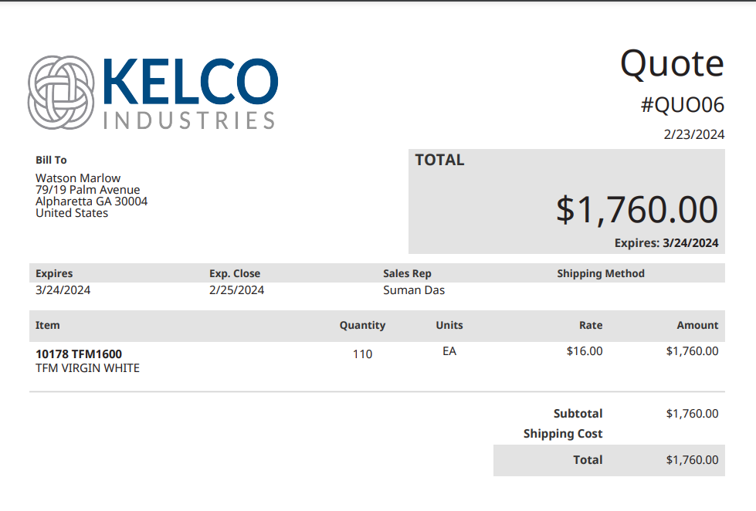
To create a sales order from the quote click the Sales Order button.
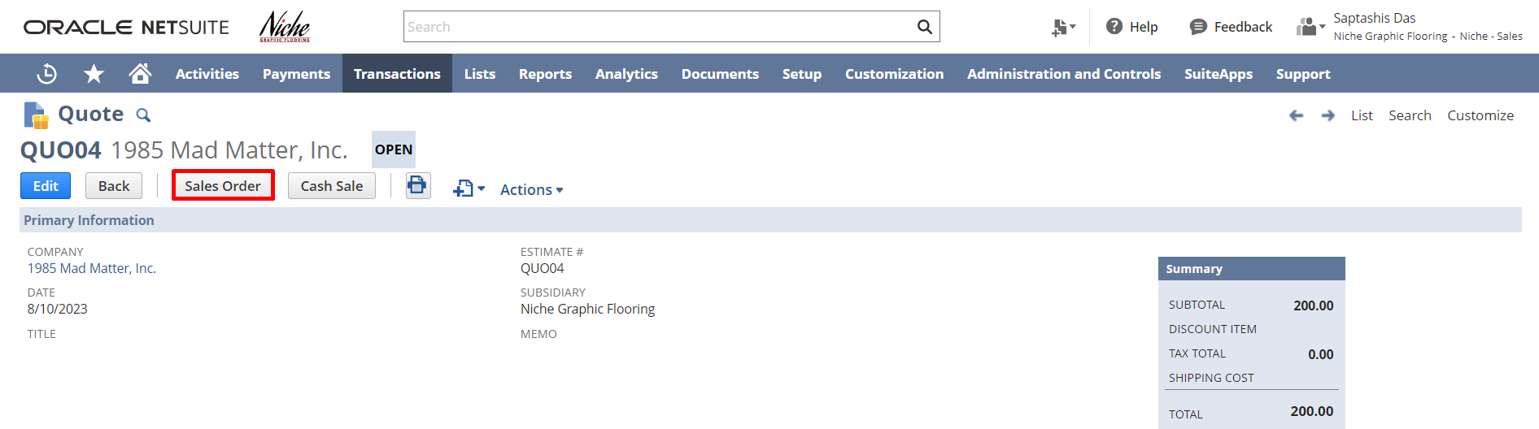
Note: As the sales order gets created and approved by the sales manager, the associated prospect record gets converted into a customer record automatically in NetSuite.

Login to Role: Sales Manager/ Administrator
Sales Preferences - Forecasts:

Before using Sales Quotas and Forecasting, please review sales preferences for Forecasts.
Navigate to Setup -> Sales -> Sales Preference

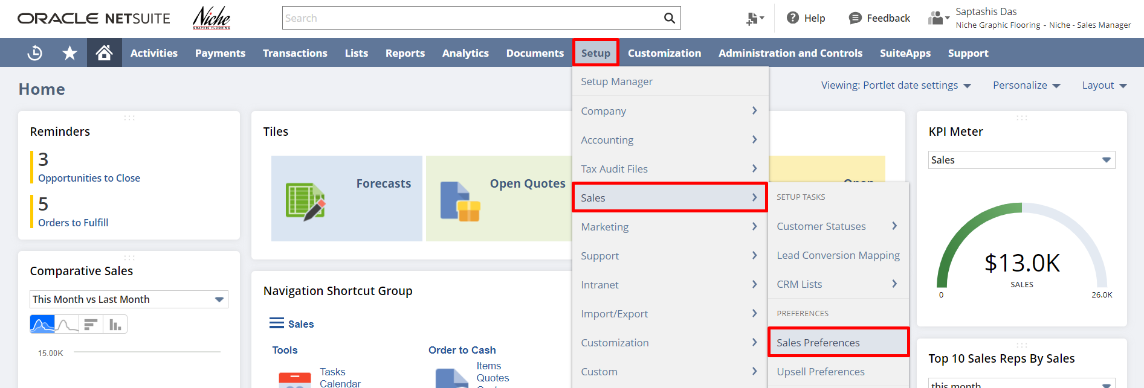

After that, click on the Forecasts subtab. Utilize the field help for detailed information regarding each preference. Enable/Disable a preference based on your requirements and Click Save.

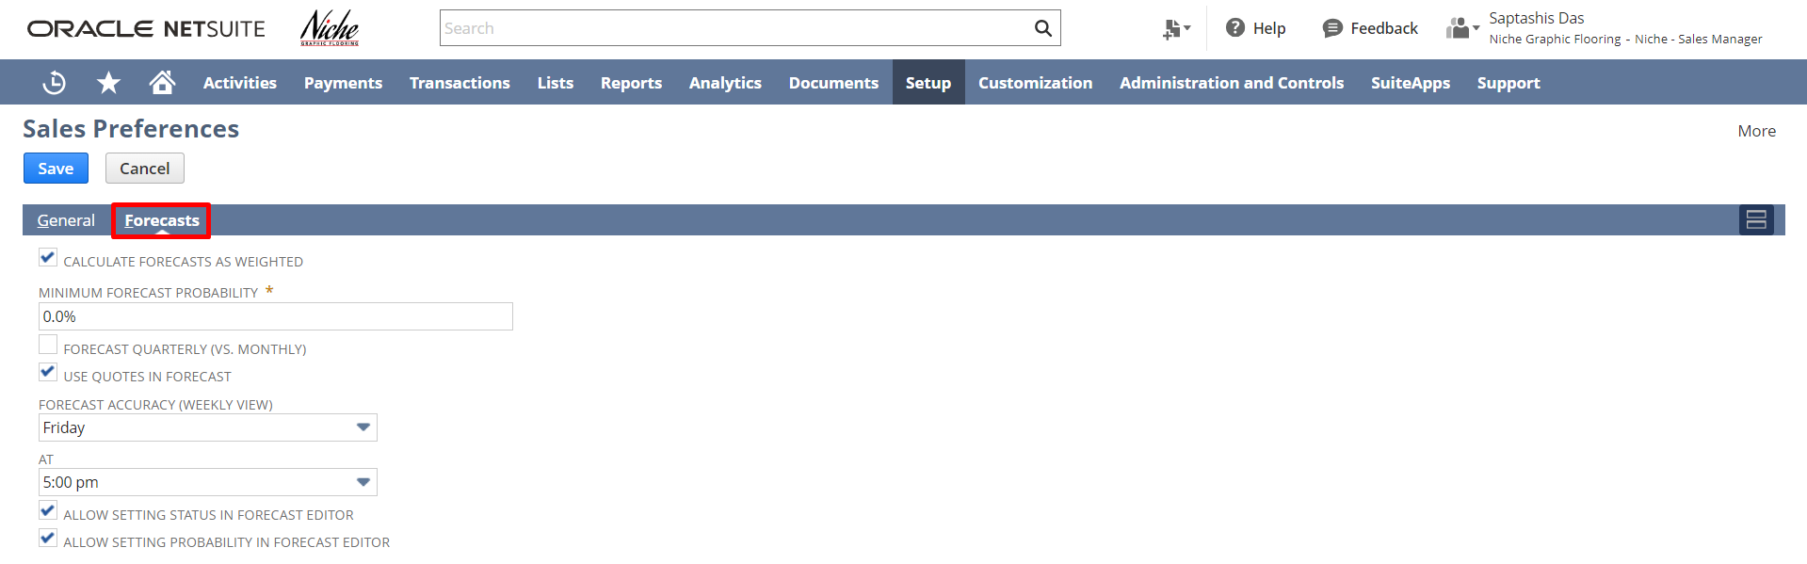

Establishing a Quota:

To create a Quota, navigate to Transactions -> Quota/Forecast -> Establish Quotas
To view the list of Quotas, click on the List option.

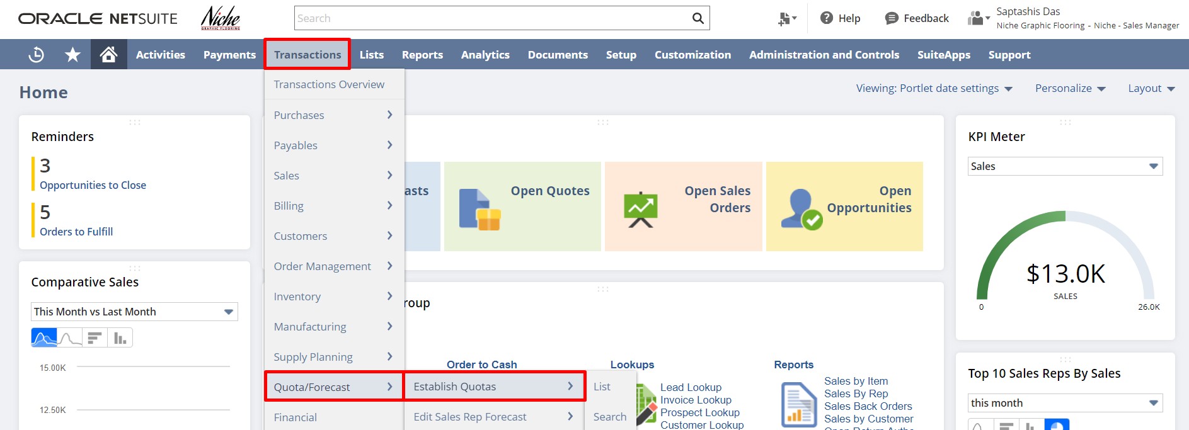

Select the Sales Rep. The Quota can be setup based on Item, Class, Location, or Department. You can check the Team Quota checkbox if you want to create the Quota as a Team Quota (Select a Sales Manager in the sales rep field).
Additionally, enter the Total and define a month-wise quota for each month or use one of the following:
Distribute: Enter the total for the entire year in the first month and click on the Distribute button. It will distribute the amount to all the months of the year and auto-fill the amount for all months.
Fill Down: Enter the amount for the first month. Click on the Fill button, it will copy the amount to all of the months with the entered amount.

After that click on the Save button.

Note: A sales manager can create a Quota for only the sales reps they supervise (must be marked as Supervisor on the employee record of the sales rep).
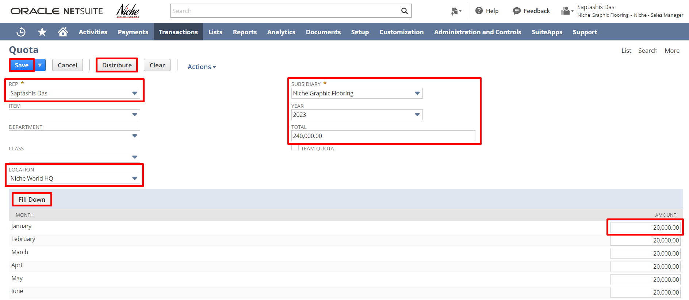

Creating a Forecast

To create a Forecast, navigate to Transactions -> Quota/Forecast -> Edit Sales Rep Forecast
To view the list of Forecasts, click on the List option.

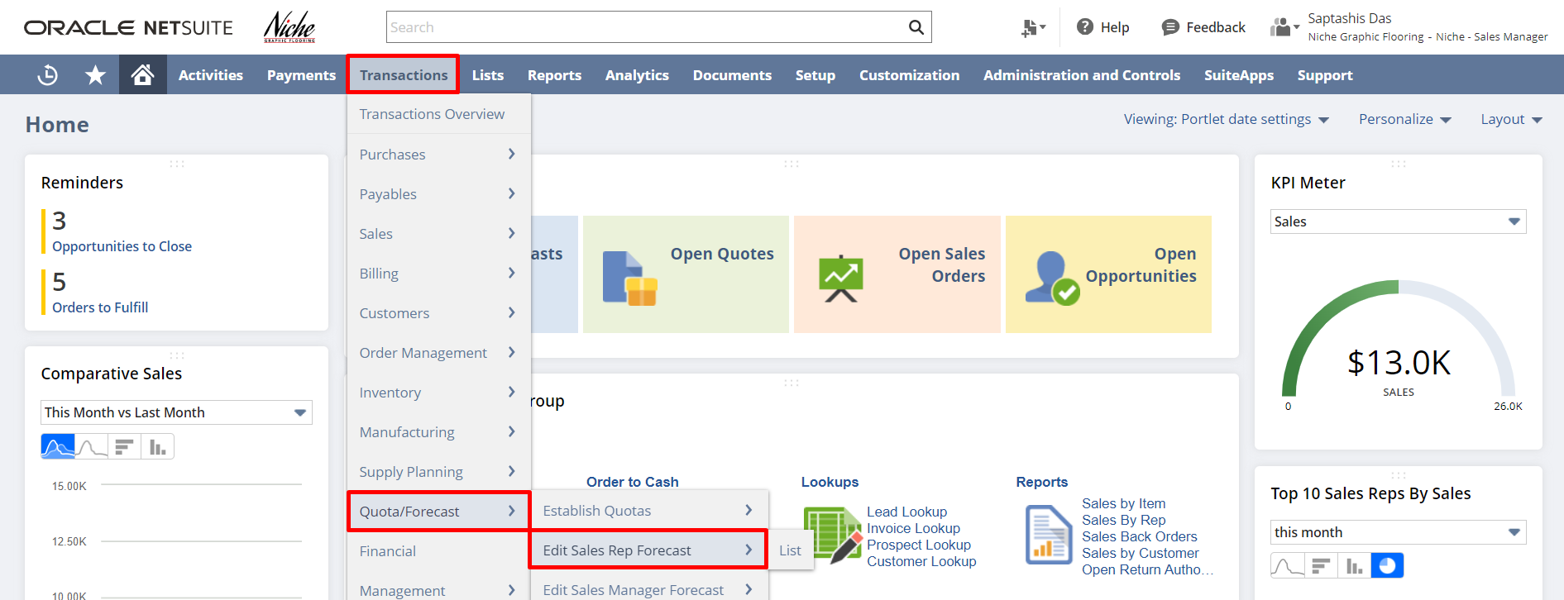

Select the Sales Rep. Change the date to choose the month for which the forecast is to be created. (User can create Quarterly Forecasts if needed by changing the preference under Sales Preferences).
On the Forecast page, you can find the four subtabs: Opportunities (Open), Quotes (Open), Unbilled Orders (Open Sales Orders), and Actuals (Open/Paid Invoices).

For Open Quotes and Opportunities, the projected total is calculated by the probability of the transaction. The weighted total after considering the probability is used in calculating the forecasted amount. Users can modify the probability as per their understanding if needed to adjust the projected total.
For Open Sales Order (Unbilled Orders tab) and Open/Paid Invoices (Actuals tab), the projected total is calculated as the total amount of the transaction (as goods have already been sold to the customer).

The sum of projected totals from Open Opportunities, Open Quotes, Open Sales Orders, and Open/Paid Invoices will be the Forecasted Amount.

Users can enter a Forecast Amount based on their understanding by ignoring the calculations made by the system in the Override field. To restore the forecasted amount to the calculations made by the system user can click on the Restored Calculated button.

After that, click on save.

In this case, we have created an Opportunity and the forecast amount is displayed depending on the Opportunity’s Weighted Total shown in the below screenshot. you can change the probability manually and the forecast amount will change accordingly.

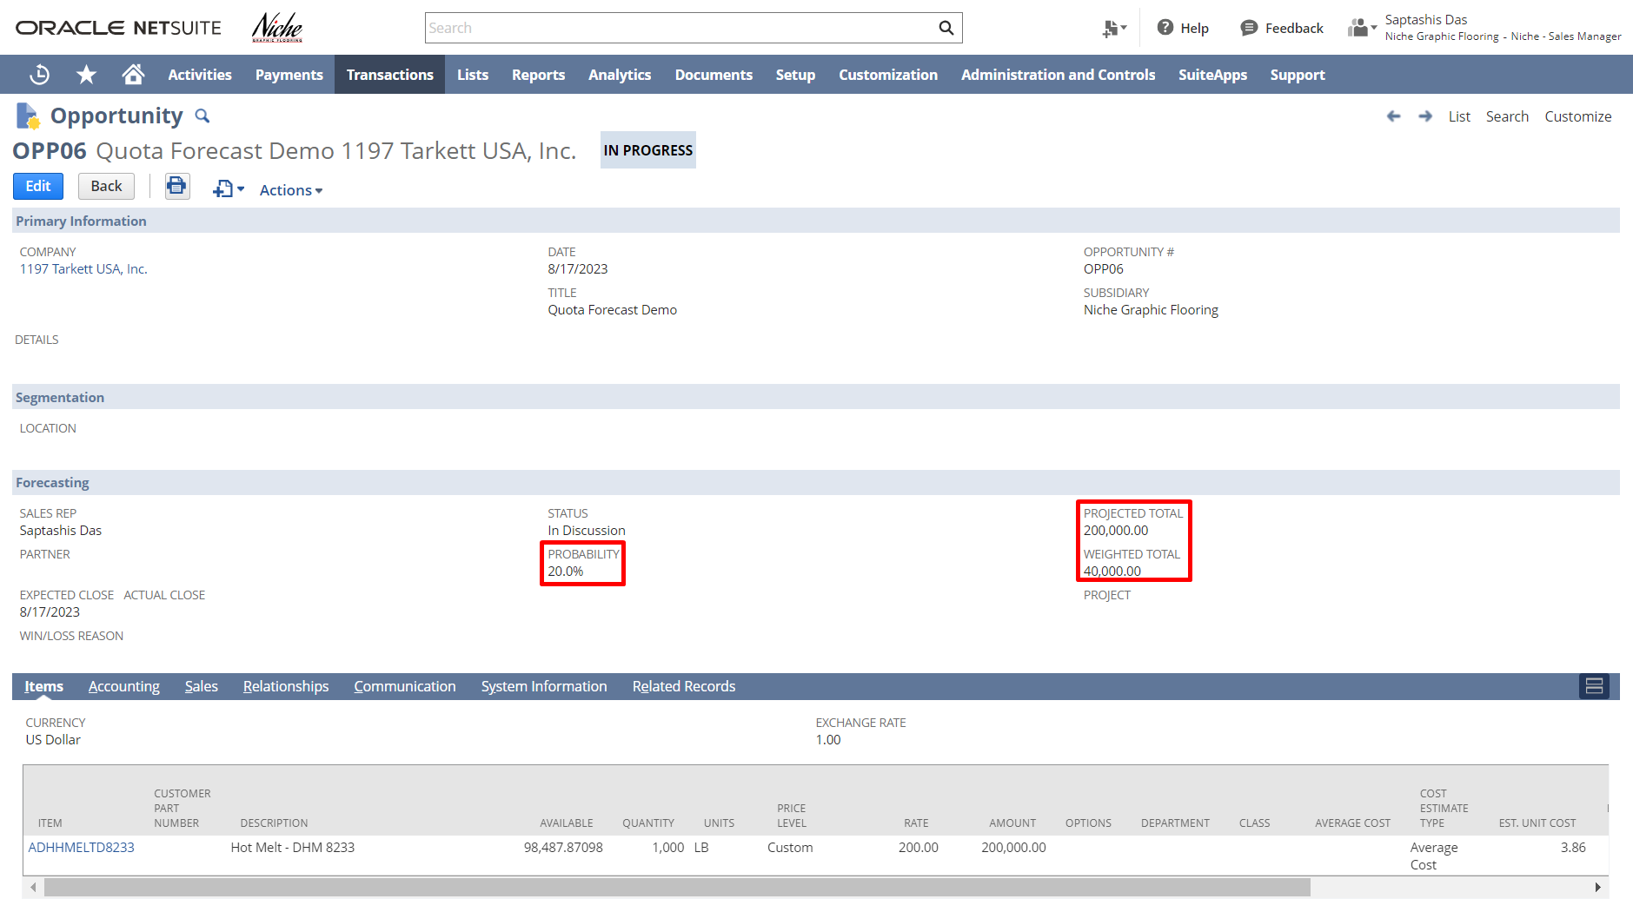

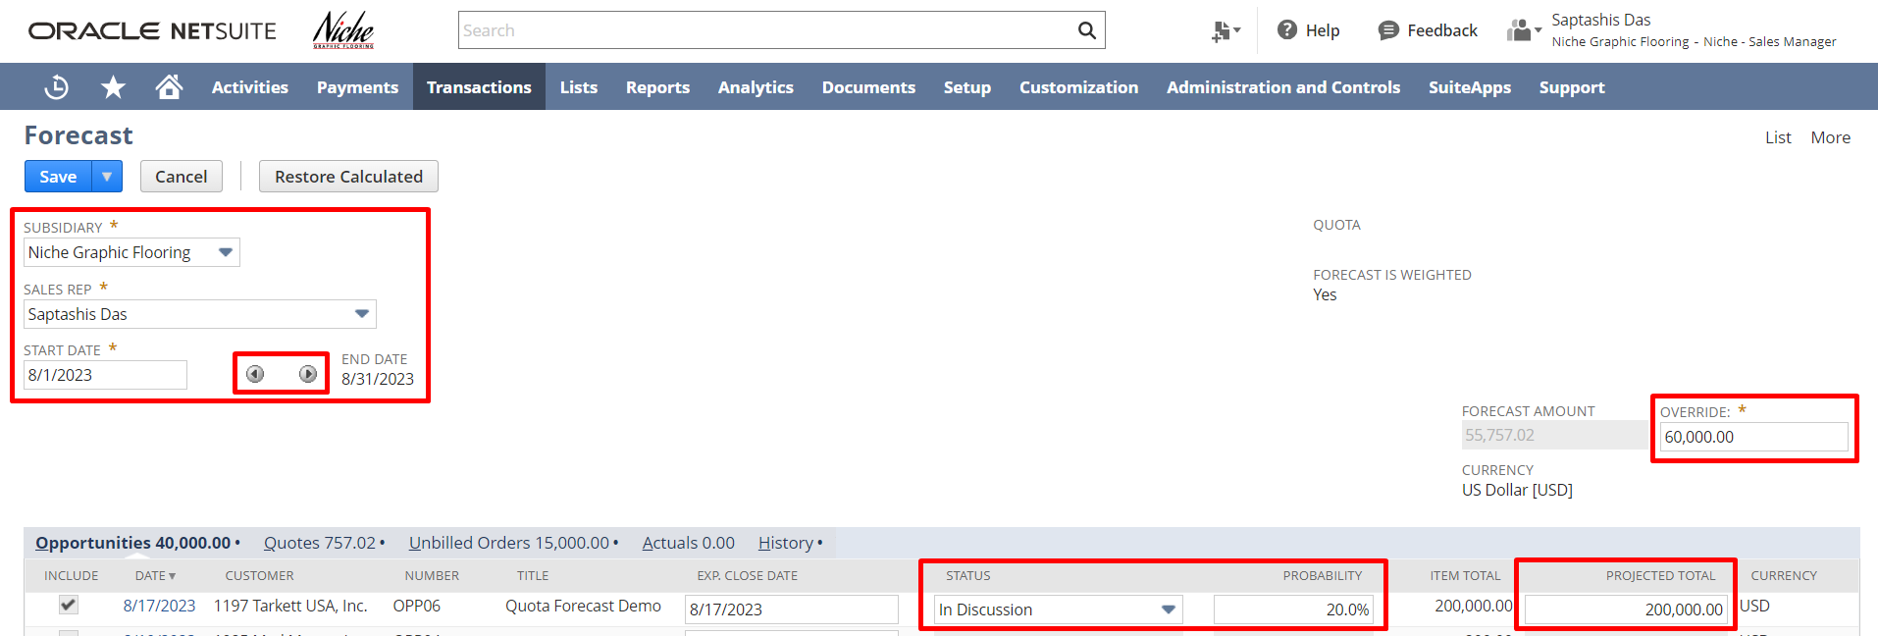

Forecast Report:

NetSuite offers a bunch of standard reports to review and tally forecasted data. You can find the list of forecast reports under Reports -> Forecast.
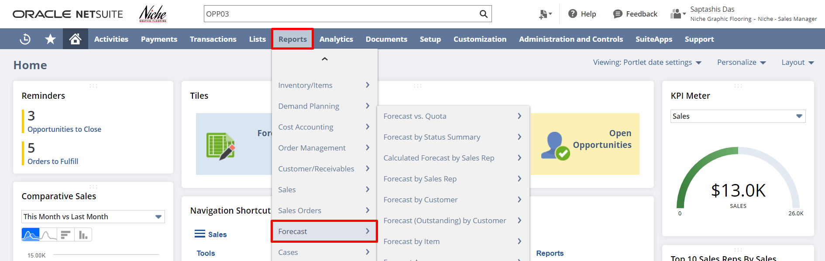

Users can review the Forecast vs. Quota Report to review the Forecast against Quota for all the sales reps. The navigation is Reports -> Forecast -> Forecast vs. Quota

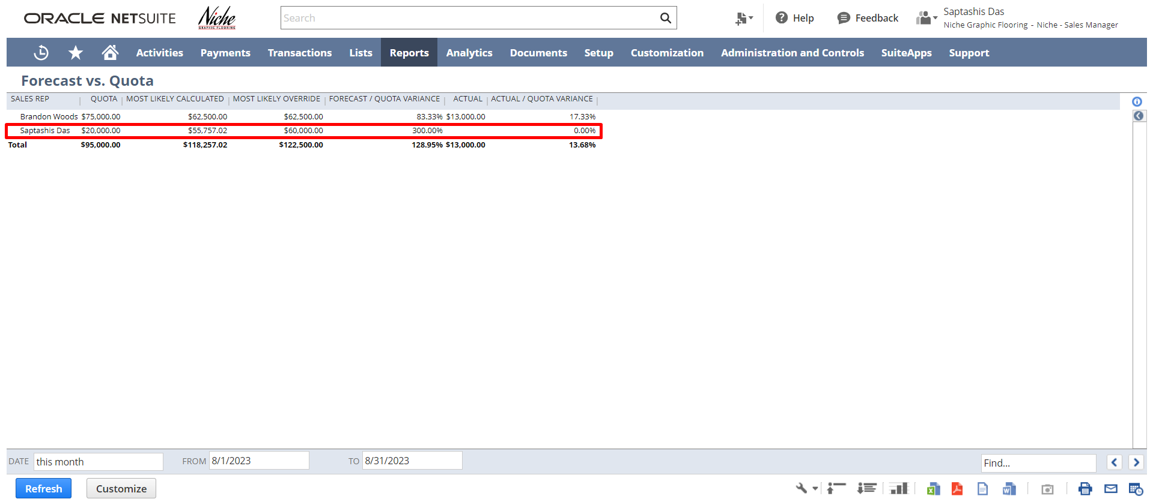

To get a detailed report click on any amount.

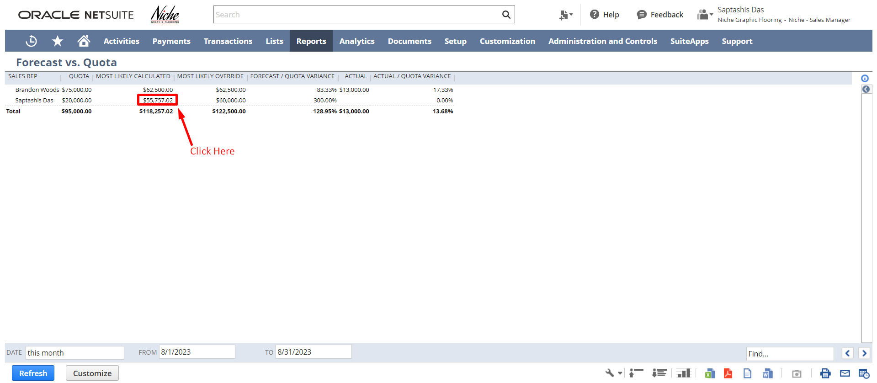

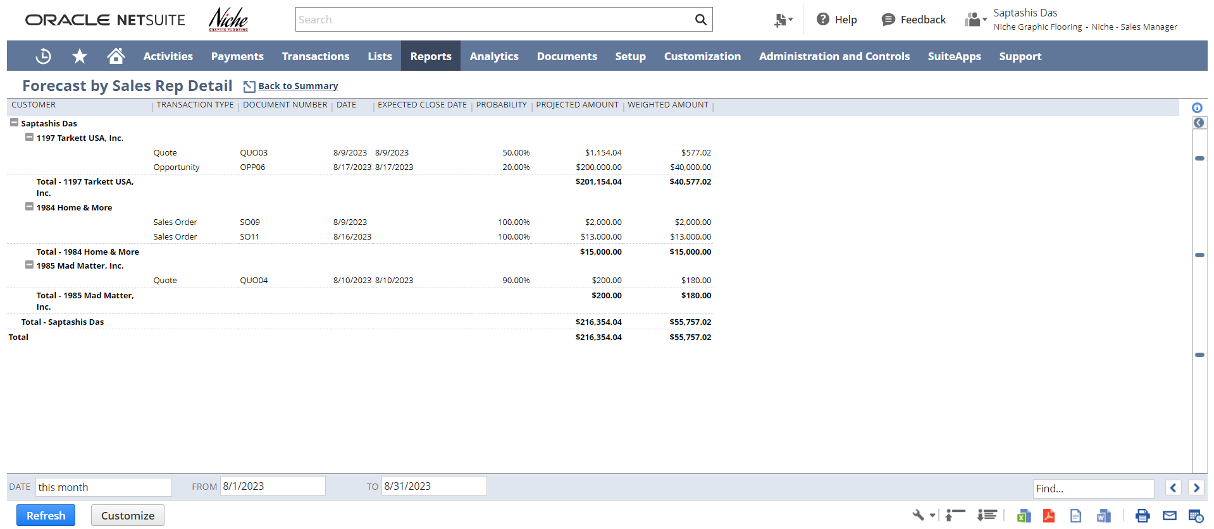

To get document details click on any document number or projected amount.
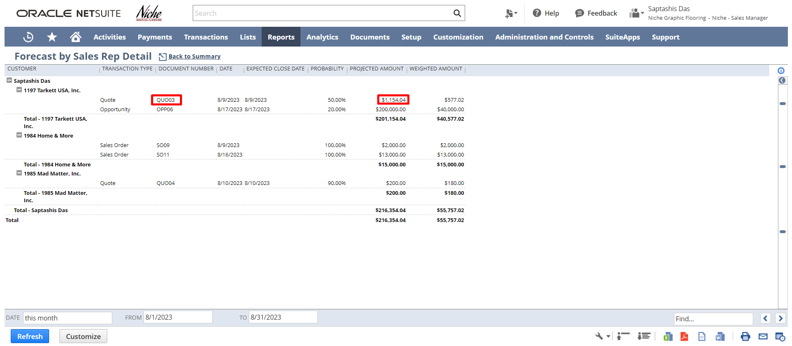

Please utilize the below feedback link for the Lead to Quote module:
https://form.typeform.com/to/woCmtXub

Signature: ________________________________
Date: _____________________________________

Disclaimer:
Upon signing off on the process flow document, you are confirming that the process has been set up per the SOW within NetSuite per your business's needs. Any changes or modifications requested after sign-off will need to be a "change request" at an additional fee.

*** PLEASE ensure that you have logged into NetSuite and tested the process prior to signing off on the setup. Paapri requires sign-off on this document prior to moving forward with any additional design meetings.

